**HMS codes modification and New functions Adding:**

1.

Domain: every user’s menu apart from the first

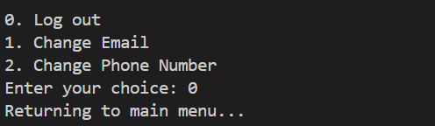  
Modification: log out -> back

**Done**

2.

  
Modification: set an input constraint to avoid invalid input

**Done**

3.

Domain: administrator

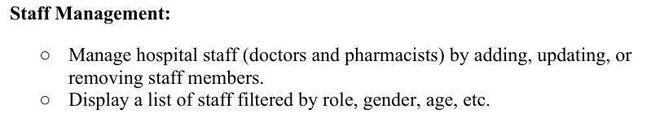

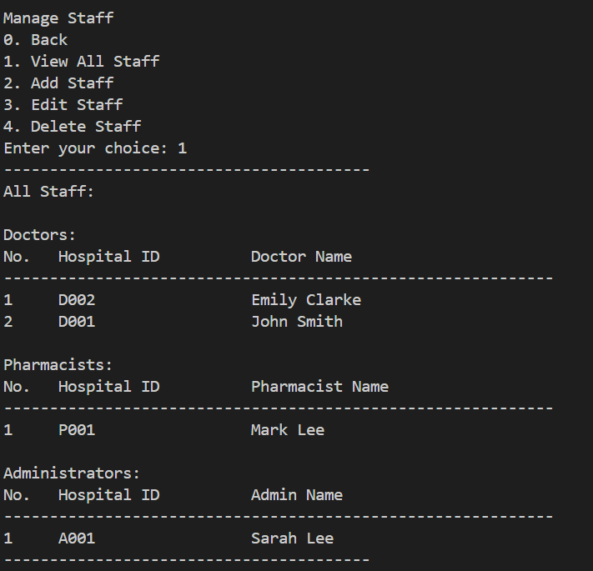

Modification: add and implement <filter> functions

**Done**

4.

Domain: doctor

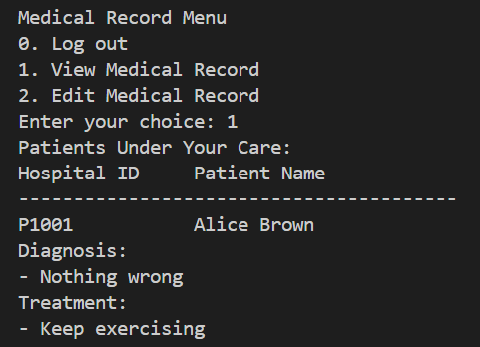

Modification: doctors should see all the messages in medical record instead of only diagnosis and treatment

**Done**

5.

Domain: administrator

  
Modification: add the function according to the description above.

**Done**

6.

Domain: administrator

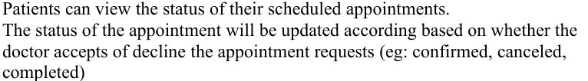

Modification: administrator should see the appointment record.

**Done  
  
Additional Functions:**

1. **Password complexity checking:**

-no less than 6 and no more than 20 characters

-must contain at least one digit, a lower case and a upper case

1. **Appointment Record Filter:**

-filtered by time

-filtered by doctor